**ARYAMAN MISHRA**

**19BCE1027**

**1.i)SRTF PROGRAM:**

#include<stdio.h>

int main(){

float arrivalTime[10], burstTime[10],remTime[10];

float waitTime[10],turnTime[10],complete[10],sumTurn=0,sumWait=0;

int process[10],remain,endTime;

int noOfProcess;

printf("Enter the no. of TrainEngine:");

scanf("%d",&noOfProcess);

for(int i=0;i<noOfProcess;i++){

printf("Enter arrival time and halt time of TrainEngine[%d]: ",i+1);

scanf("%f %f",&arrivalTime[i],&burstTime[i]);

process[i]=i+1;

remTime[i]=burstTime[i];

}

remTime[9]=9999;

for(int time=0;remain!=noOfProcess;time++){

int smallest=9;

for(int i=0;i<noOfProcess;i++){

if(arrivalTime[i]<=time &&remTime[i]<remTime[smallest] &&

remTime[i]>0){

smallest=i;

}

}

remTime[smallest]--;

if(remTime[smallest]==0){

remain++;

endTime=time+1;

turnTime[smallest]=endTime-arrivalTime[smallest];

waitTime[smallest]=turnTime[smallest]- burstTime[smallest];sumWait+=waitTime[smallest];

sumTurn+=turnTime[smallest];

printf("%f",turnTime[smallest]);

}

}

printf("\n\nTrainEngineId\tArrival\t\tTrainHalt\t\tTurnTime\tWaitTime\n");

for(int i=0;i<noOfProcess;i++){

printf("T[%d]\t\t10.%.0f\t\t%.2f\t\t\t%.2f\t\t%.2f\n",i+1,arrivalTime[i],burstTime[i],turnTime[i],waitTime[i]);

}

printf("\n\nAvg. wait time of a Bus: %.2f",sumWait/noOfProcess);

printf("\nAvg. turn around Bus: %.2f\n",sumTurn/noOfProcess);

}

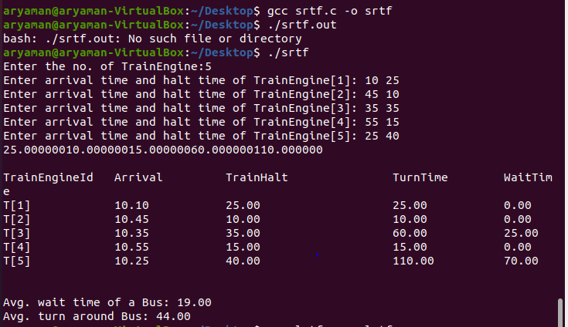

**1.ii)LRTF PROGRAM:**

#include<stdio.h>

int main(){

float arrivalTime[10], burstTime[10],remTime[10];

float waitTime[10],turnTime[10],complete[10],sumTurn=0,sumWait=0;

int process[10],remain,endTime;

int noOfProcess;

printf("Enter the no. of TrainEngine:");

scanf("%d",&noOfProcess);

for(int i=0;i<noOfProcess;i++){

printf("Enter arrival time and halt time of TrainEngine[%d]: ",i+1);

scanf("%f %f",&arrivalTime[i],&burstTime[i]);

process[i]=i+1;

remTime[i]=burstTime[i];

}

remTime[9]=-1;

for(int time=0;remain!=noOfProcess;time++){

int largest=9;

for(int i=0;i<noOfProcess;i++){

if(arrivalTime[i]<=time &&remTime[i]>remTime[largest] &&

remTime[i]>0){

largest=i;

}

}

remTime[largest]--;

if(remTime[largest]==0){

remain++;

endTime=time+1;

turnTime[largest]=endTime-arrivalTime[largest];

waitTime[largest]=turnTime[largest]- burstTime[largest];

sumWait+=waitTime[largest];

sumTurn+=turnTime[largest];}

}

printf("\n\nTrainEngineId\tArrival\t\tTrainHalt\t\tTurnTime\tWaitTime\n");

for(int i=0;i<noOfProcess;i++){

printf("T[%d]\t\t10.%.0f\t\t%.2f\t\t\t%.2f\t\t%.2f\n",i+1,arrivalTime[i],burstTime[i],turnTime[i],waitTime[i]);

}

printf("\n\nAvg. wait time of a Bus: %.2f",sumWait/noOfProcess);

printf("\nAvg. turn around Bus: %.2f\n",sumTurn/noOfProcess);

}

